Walk-through guide to using the HEPT

# Section 1: QuPath

1. Open the QuPath project and load your project’s H&E image.
   1. HEPT_QuPath_Project > project.qpproj
   2. Alternatively, create your own QuPath project and move the classifiers and scripts into your project folder.
      1. HEPT_QuPath_Project > classifiers > pixel_classifiers
         1. Preprocessing_model.json
         2. Strict_model.json
      2. HEPT_QuPath_Project > scripts
         1. QuPathScript.groovy

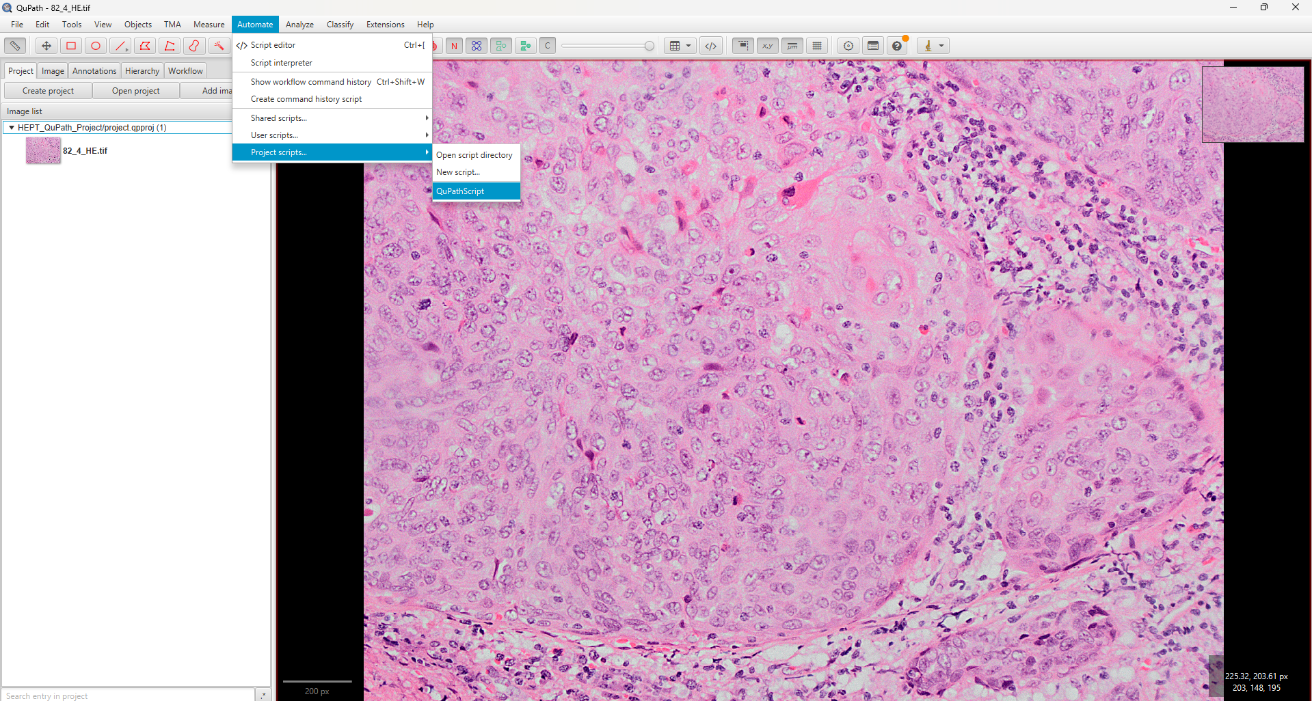

1. Run the QuPathScript.groovy to apply the two pixel classifiers to all images in your project.
   1. Note: Change the path for the output images of the two models.

# Section 2: ImageJ & Stardist

1. The output of QuPath returns images in the ome.tif format which can be split into their individual images with an ImageJ macro.
   1. You may use the StackSplit.ijm macros in FIJI to automate this step.
   2. There are two ImageJ macros, one for the output of each QuPath pixel classifiers (Preprocessing_model and Strict_model).

1. Run the pre-trained Stardist model for H&E singe-cell segmentation using the macro in ImageJ (HEPT_Stardist_FIJIMacro.py).

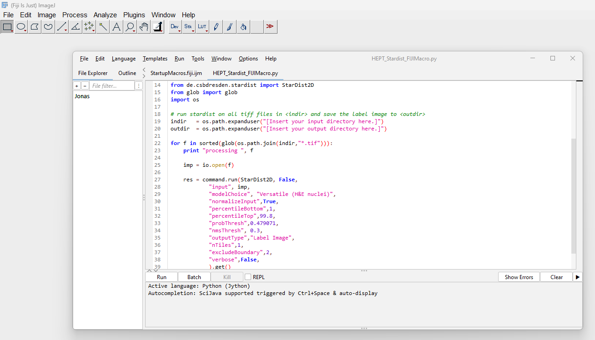

# Section 3: CellProfiler

1. Load the CellProfiler pipeline (HEPT_Pipeline.cproj) along with all the outputs from the various previous steps. There should be a total of 7 channels per H&E photomicrograph:
   1. Original H&E photomicrograph
   2. Output from QuPath Preprocessing_model:
      1. Stroma (Str)
      2. Nuclei (Nuc)
      3. Background (Bg)
   3. Output from QuPath Strict_model:
      1. Immune Cells (ImmC)
      2. Others
   4. Stardist objects
2. Go to the FilterObjects modules #13-#16 and load the CellProfiler Analyst model (CPA_Model_1).

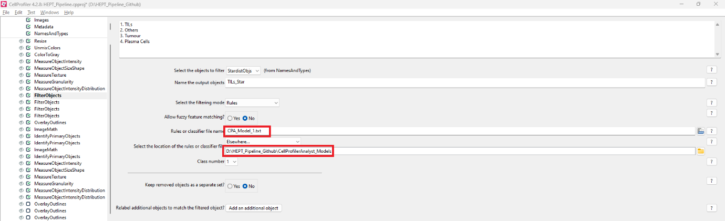

1. Similarly, go to FilterObjects modules #28, #29 and load the CellProfiler Analyst model (CPA_Model_2).
2. Finally, go to FilterObjects modules #32, #33 and load the CellProfiler Analyst model (CPA_Model_3).
3. Add your own local output folder in the last module, ExportToDatabase #61.

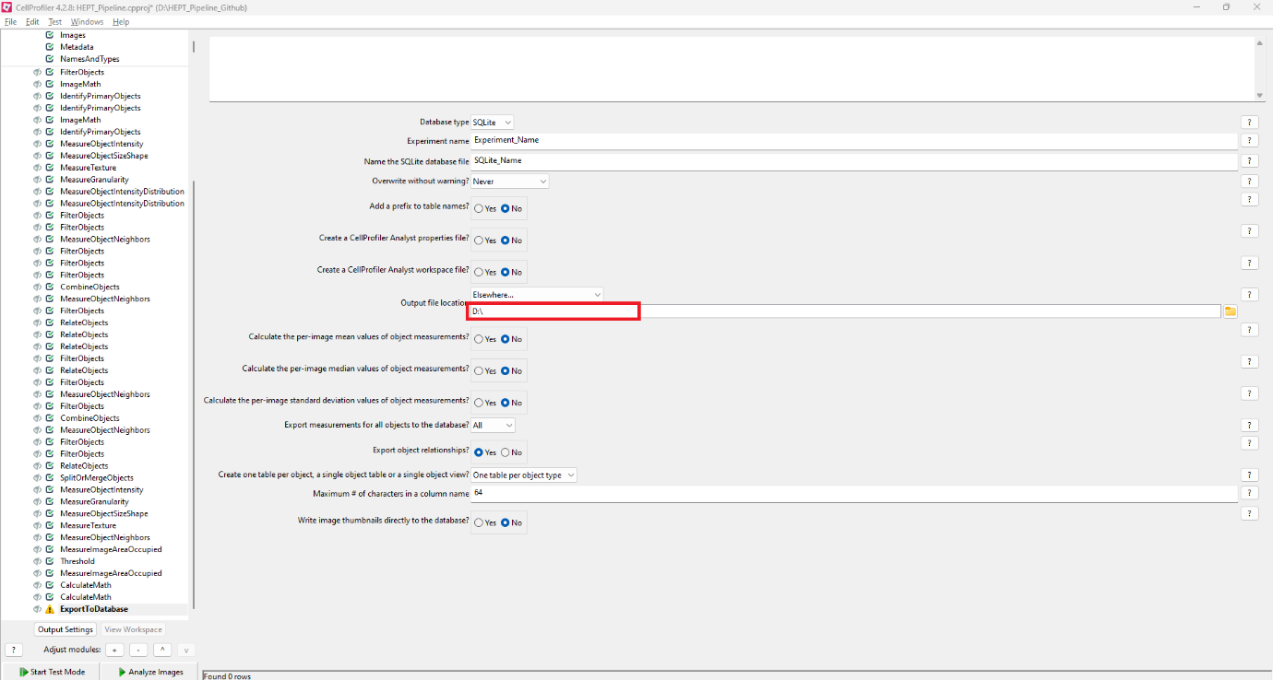

1. Run the CellProfiler pipeline on all images in your project.